Experiment No: 1

**Aim: Case study of Open Web Analytics**

**Theory:**

**Introduction:**

Web Analytics is the free and open source web analytics framework that lets you stay in control of how you instrument and analyze the use of your websites and application. Web analytics is a powerful tool for any business with a website or an online presence. By monitoring how prospective customers and visitors interact with your online resources, you can move on to tailoring these experiences with the aim of increasing your sales, clicks, and conversions.

# Development Details:

Open Web Analytics (OWA) is open-source web analytics software created by Peter Adams. OWA is written in PHP and uses a MySQL database, which makes it compatible for running with an AMP solution stack on various web servers.

# Features:

* Track Page views, visits, and unique visitors over time
* Track unique, new, repeat visitors over time
* Multiple Web Site Support - track any number of web sites and view statistics in aggregate or by site
* Google Maps - map your visitors on Google Maps
* Google Earth (KML) - view your visitors in Google Earth via a KML file export
* RSS/ATOM subscription tracking - track unique feed readers, reader types, and feed requests
* Visitor Aging - understand the age of your repeat visitors.
* Canned and Custom Time Periods - generate reports using pre-defined reporting periods or custom date ranges
* Refering Page Analysis - View the title, anchor text, and surrounding text of inbound links from refering web pages
* View visits by user agent
* Track entry and exit pages

# How to use:

* **Installation:**
* Download the latest version of Open Web Analytics from the official website or repository.
* Follow the installation instructions provided in the documentation.
* Set up a MySQL or PostgreSQL database for OWA.
* Configure the necessary settings during the installation process.

# Integration with Your Website:

Once OWA is installed, you need to integrate it with your website. This typically involves adding a tracking code to your website's HTML.

The tracking code is generated during the installation process. You can find it in the OWA dashboard under the "Site Configuration" section.

# Tracking Code Placement:

Place the tracking code in the HTML of your website. This is usually done in the

<head> section of each page you want to track.

If you are using a content management system (CMS) like WordPress, there might be plugins available to simplify the integration.

Accessing the Dashboard:

After integration, you can access the OWA dashboard by navigating to the OWA installation directory in your web browser.

Log in using the credentials you set during the installation.

# Navigating the Dashboard:

The OWA dashboard provides various sections to analyze data, including visitors, referrers, pages, and more.

Explore different sections to gain insights into your website's performance and user behavior.

# Maintenance and Updates:

Regularly update your OWA installation to benefit from the latest features and security patches.

Check the documentation for any additional configuration or maintenance tasks.

# Application:-

**Website Owners:**

Individuals and businesses with their own websites can use OWA to gain insights into user behavior, traffic patterns, and the effectiveness of their online content.

# Webmasters and Developers:

Webmasters and developers responsible for maintaining and optimizing websites can use OWA to monitor website performance, identify issues, and make data-driven decisions for improvements.

# Digital Marketers:

Digital marketers can leverage OWA to analyze the effectiveness of marketing campaigns, track conversion goals, and understand user engagement to refine their strategies.

# Content Creators:

Bloggers, writers, and content creators can use OWA to analyze the popularity of their content, identify trending topics, and tailor their content strategy based on user preferences.

# Small Businesses and Startups:

Small businesses and startups with limited budgets can benefit from OWA as a cost- effective solution for understanding website traffic and user behavior.

# Educational Institutions:

Universities, colleges, and educational institutions can use OWA to analyze website traffic on their official sites, understand user engagement, and make data-driven decisions for improving online resources.

# Nonprofit Organizations:

Nonprofit organizations can use OWA to track the performance of their websites, analyze donation trends, and understand how users interact with their online content.

# Open Source Enthusiasts:

Individuals and organizations that value open-source solutions can contribute to the OWA project, customize the tool to suit their needs, and benefit from the collaborative nature of the open-source community.

# Privacy-Conscious Users:

OWA allows users to configure privacy settings, making it suitable for those who prioritize user privacy and comply with regulations like GDPR

. 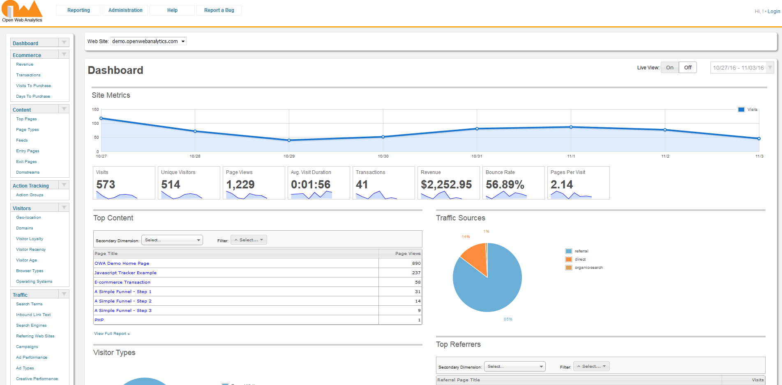

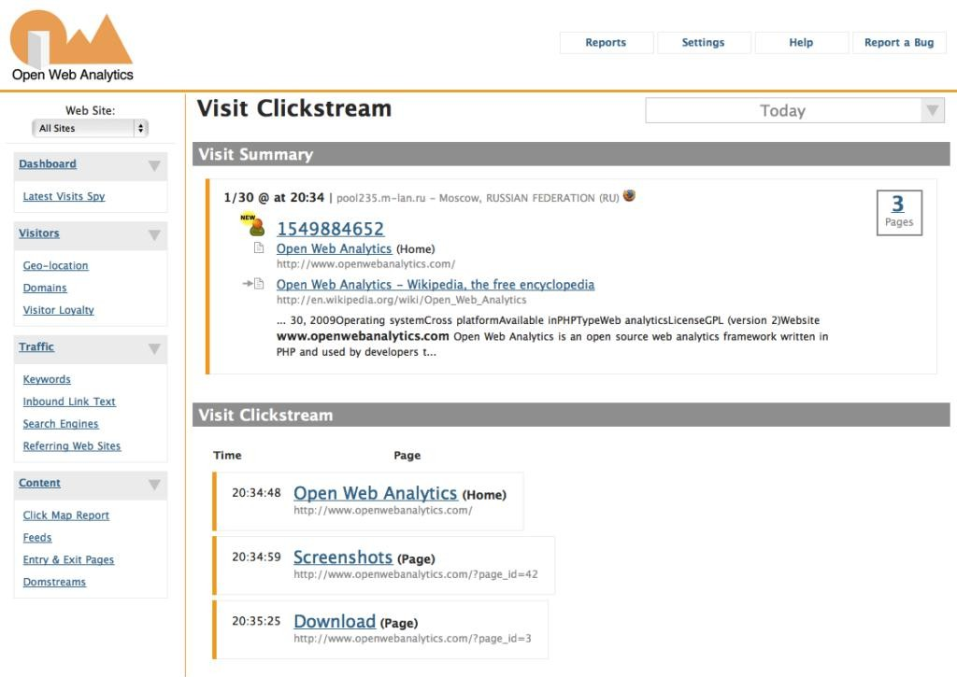

# Conclusion:

Web analytics tools are indispensable for any website owner or marketer seeking to gain a competitive edge in the online world. They provide valuable insights into the performance of digital marketing.